Contemplative Outreach Rochester NY Chapter
Springtime-We’re Growing!
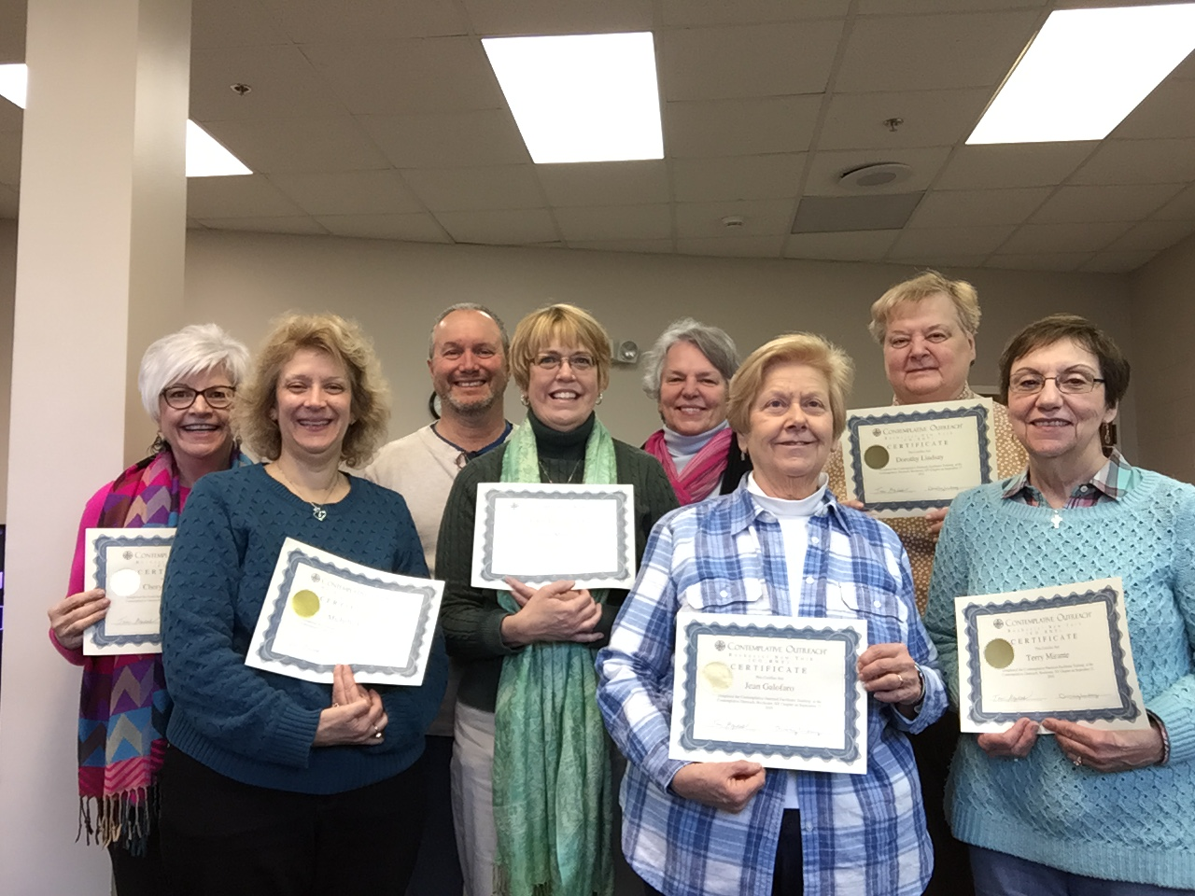
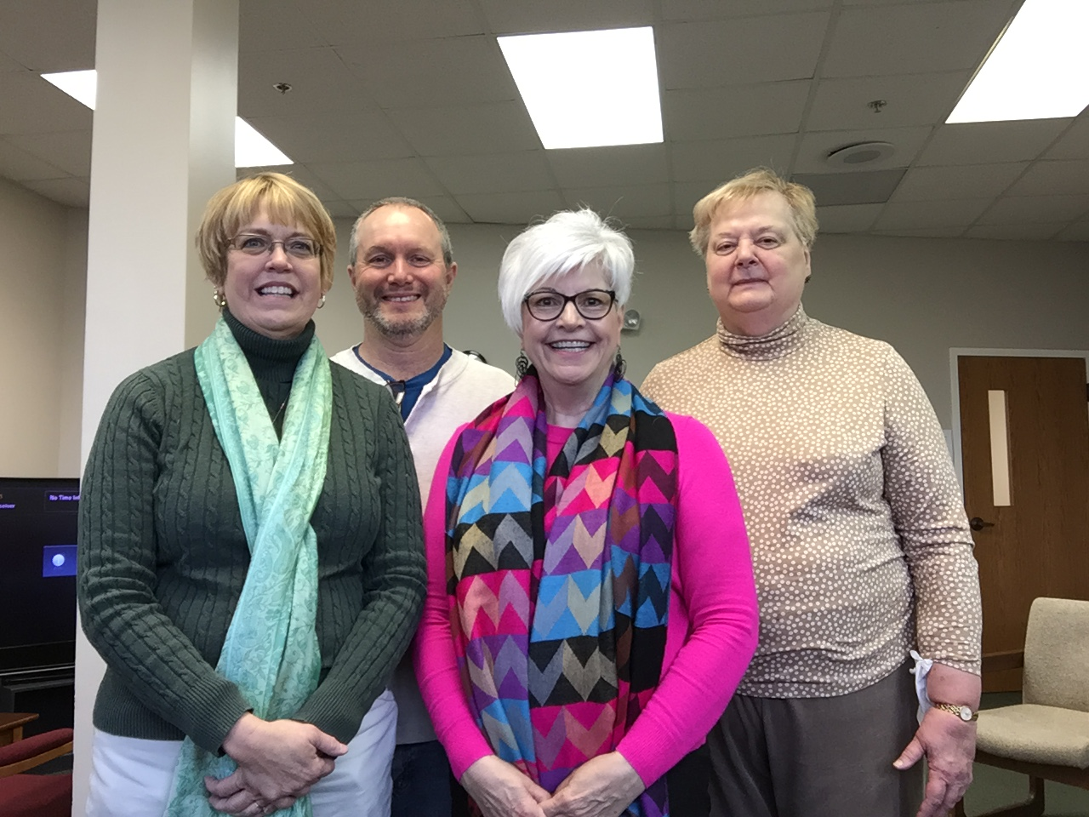
Hurray! Our very first newsletter!

What’s New…

Expanded meetings:
- Tuesday-Westside Group (Greece) 26 Old Meadow Drive, Rochester, NY 14626. (2nd and 4th Tuesday of each month at 4:00-5:00) Call Cheryl McElhatten for information at 585-749-9225
- Wednesday- Eastside Group-Church of the Assumption, 20 East Avenues, Fairport, NY 14450. Meets weekly in room 2 of the lower level. Call Janie Marini for information at 585-943-4913.

Are you interested in a deeper relationship with God in Centering Prayer?
- Read “Open Mind, Open Heart” , “Invitation to Love”, and “Intimacy with God” by Fr Thomas Keating.
- Go to www.ContemplativeOutreach.org to find many resources: articles on Centering Prayer and many additional resources, i.e., books, online videos, DVD’s, podcasts and much more.

Want to Deepen your practice?
- Establish a practice of two-20 minute prayer times.
- Join a CP group.
- Go on a retreat.
- Attend “Days for Centering Pray-ers”.

May we introduce… our facilitators

“The Divine Presence: …is happening in, through, and amidst every detail of life…penetrates all that exists…is in relationship to every part of creation…is trying to move humanity to the next stage of consciousness”-Fr Thomas Keating-“God is Love: The Heart of All Creation”

God is Love: The Heart of All Creation, Thomas Keating 2017 Dvd

Left to right: Janie Marini, Tom Agness, Cheryl McElhatten, Dorothy Lindsay

and our leadership team!

Left to right: Cheryl McElhatten, Michelle Peter, Tom Agness, Janie Marini, Mary Jo Bender, Jean Galofaro, Dorothy Lindsay, Terry Mirante

What's Next?
Come and See…
What: United in Prayer Day Rochester NY
When: March 18, 2017
Where: St Anne’s on 1600 Mt Hope Ave, Roch, NY
Time: Gather at 9:00AM, Begin at 9:30, End at Noon
Other: Donation: $10, Walk-ins welcome. Please bring a friend.
RSVP: By Friday-March 10, to Tom Agness at 585-349-8286 or lemeorco@yahoo.com
Let's pray in solidarity, share, and celebrate.

What: Introduction to Centering Prayer Workshop
Saturday- First Session: March 25- 9:30-3:00
Second Session-Monday- April, 3 1:00-3:30
Third Session-Monday- April, 17 1:00-3:30
Fourth Session-Monday- April, 24 1:00-3:30
(other times negotiable)

Fee for all 4 Sessions is $95.00
Fee for Session 1 is $50.00
Fee for Sessions 2-4 is $60.00
Bring your own lunch-beverages and dessert provided

Where: Mercy Spirituality Center, 65 Highland Ave, Rochester, NY 14620, Register with MSC at
info@mercyspiritualitycenter.org or Call Goldie at
(585) 473-6893

Questions: Please call Dorothy Lindsay at (585) 203-1271.

What: Five Day Centering Prayer Retreat
Presenter: Sr Rita Panciera, RSM
When: Monday July 24- Saturday July 29, 2017
Where: Mercy Spirituality Center, 65 Highland Ave Rochester, NY 14620
Why Go On Retreat?
By Mary Jo Bender

As I watched the movie “The Way” (a film about the El Camino, a pilgrimage in Europe), I thought that people make retreats for many reasons.

On reflection of this movie and my own experiences, I offer you a glimpse into my thoughts.
When I think of making a retreat, I think of a chance to step aside from life for awhile…rest and become refreshed in a nurturing and peaceful environment. I personally get busy with life, grandchildren, family, friends, my home and projects. Taking time for my prayer practice, silence and reading are very important to me. I make time everyday for these moments.

It brings me solitude, refreshment and a sense of being with my God. From these practices, over time I feel and see differences in my body, mind and my soul. In order to take time for serious reflection of my life, I need time alone, in silence, where the worries of family, friends, life or anything are absent and I am just being with God.

I think it is important for me, to make a retreat...to take that step to slow down and just be. This helps to support and deepen all of the practices that I do. Our entire being responds with permission to reflect and explore those things we don’t often have enough time for. When on retreat, I am with like minded people, I am restful, reconnecting, balancing and getting different perspectives. I don’t have to do the everyday. I am off all cyber communications. I have time to meet with someone for direction. I can nap, walk, read and focus on just my spiritual life.

When I come home, I feel refreshed, full of desire to carry these feelings, thoughts and prayers into my everyday. I choose the Mercy Spirituality Center, Omega Institute and day retreats.

Why do you go on a retreat?...have you?... Where do you go?…have you looked into a place? I encourage you, to take the time and step aside.

How has Centering Prayer Affected your life?

Almost all of my life I've been a “do-er" . It's really my temperament . Even in my spiritual life I thought I had to "do" something to please God; to get God's favor and attention.

So the invitation to Centering Prayer came as a surprise to that busy self. It was unfamiliar and difficult to "just" rest with God. Now after several years of Centering Prayer it is still a mystery to me to find myself embracing that "Nothing". Yet I know it is good, very, very good.

In my senior years now I am not so much of "do-er" - in my natural life nor in my spiritual life. Perhaps the Spirit called me to this form of prayer to prepare me for a more contemplative life at this time in my life - to relax with God in peace and joy.

AND with great joy we announce…

Our COR_NY website contemplativeoutreachrny.com with events, photos, group meetings list, links to retreat centers with programs and locations.

With gratitude…Cheryl McElhatten is now certified by Contemplative Outreach Ltd. as a Presenter of the Introduction to Centering Prayer in addition to Tom Agness, Dorothy Lindsay and soon to be certified Janie Marini.

Editor: Cheryl McElhatten silvrfox@rochester.rr.com

Contributors: Mary Jo Bender, Jean Galofaro, Dorothy Lindsay

